Where to now for a nuclear free and independent Pacific?
by Marco de Jong & Talei Mangioni | Nov 19, 2023 | 0 | 10 min read E tangata
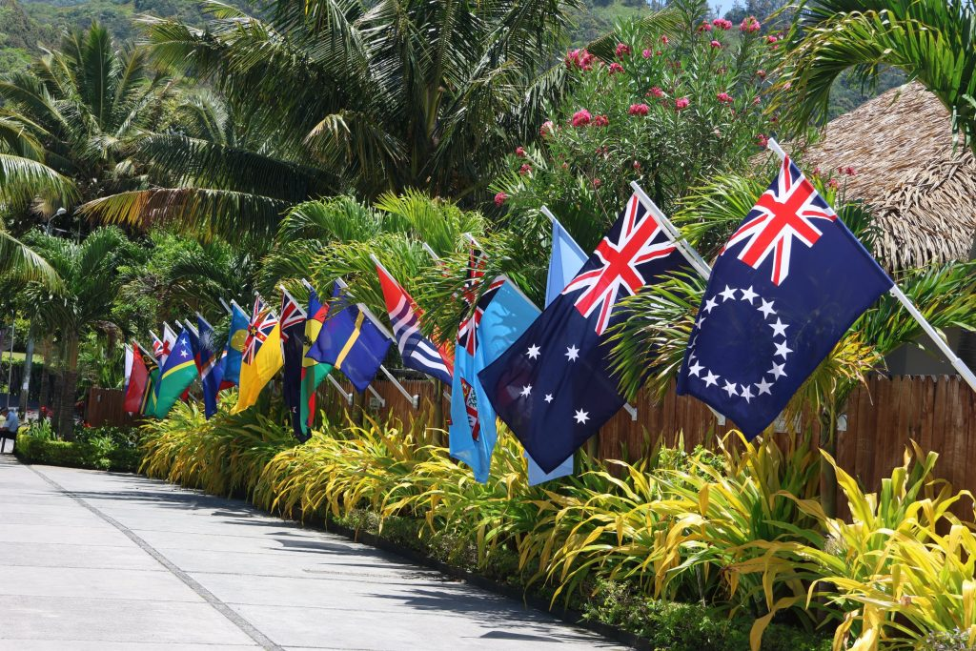
“Our nuclear-free status is tied in intimate ways to our political independence — and ultimately to our survival as peoples of the Pacific.” — Dr Marco de Jong and Talei Mangioni. (Photo: Pacific Islands Forum)
Pacific historians Marco de Jong and Talei Mangioni were in Rarotonga for this year’s Pacific Islands Forum leaders meeting which wrapped up just over a week ago. They wanted to get an on-the-ground perspective of regional politics in action.
But, as advocates for a nuclear-free and independent Pacific, they came away somewhat disheartened.

The competition for influence in the Pacific has resulted in a worrying series of regional developments. We believe the superpowers are working to undermine the independence and power of the Pacific Islands Forum and our nuclear-free status, which they see as an impediment to their military interests.
Most concerning is the role Australia has carved out for itself in its pursuit of strategic influence — and the way this has skewed its priorities and partnerships with other members of the Pacific Islands Forum.
To really understand what’s at stake, we need to look at the Treaty of Rarotonga, which is the centrepiece of the Pacific’s nuclear-free legal regime.
The agreement, signed at the 16th South Pacific Forum in Rarotonga in 1985, banned the possession, testing, stationing, and storage of nuclear weapons, as well as the dumping of nuclear waste in the South Pacific Nuclear Free Zone. It reflected decades of opposition to nuclear colonialism by activists from the Nuclear Free and Independent Pacific movement, alongside policymakers in regional forums.
However, as is often the case with international agreements, the Rarotonga treaty represents compromise rather than consensus, and contains a number of loopholes. These have become significant in the context of AUKUS (the nuclear submarine pact between Australia, the US and the UK).
When the treaty was drafted in the 1980s, Australian prime minister Bob Hawke and New Zealand prime minister David Lange put pressure on Pacific nations to word it in a way that would allow the US to sign. They argued that the US was better in than out.
Specifically, provisions were made that allowed nuclear weapons and nuclear-powered ships to transit through the zone. These were heavily criticised at the time by civil society and several Pacific nations, notably Vanuatu and the Solomon Islands, which initially refused to sign the treaty.
But despite those accommodations, the US has never ratified the treaty protocols — and it remains non-committal despite repeated reminders over the years. Most notably in 2012, when it was raised with then-US secretary of state Hillary Clinton at the 43rd Pacific Islands Forum — and most recently at last year’s US-Pacific Islands Country Summit in Washington.
At this year’s Forum summit in Rarotonga last week, it was rumoured that there were plans to “revitalise” the Rarotonga treaty. We asked Mark Brown, the Cook Islands prime minister and chair of the Forum, what that might mean.
“When the treaty was endorsed in 1985, the global situation was very different,” he told us. As he put it, revitalisation is about the “leaders of today revisiting that treaty and putting our concerns about nuclear issues into a modern context”.
That sentiment reflects the fact that a nuclear-free Pacific is unlikely to be a priority in the growing geopolitical agendas of the US and China. Both are nuclear-weapon states, and both are contributing to increasing militarism in the region.
And while almost all Pacific leaders at the meeting supported a revitalised Treaty of Rarotonga — including Carmel Sepuloni, who represented our caretaker government alongside National’s foreign affairs spokesman Gerry Brownlee — Australia seemed more interested in containing the issue. Asked whether he’d support Pacific calls for the US to ratify the treaty protocols, Anthony Albanese, Australia’s prime minister, said the US didn’t need his advice.
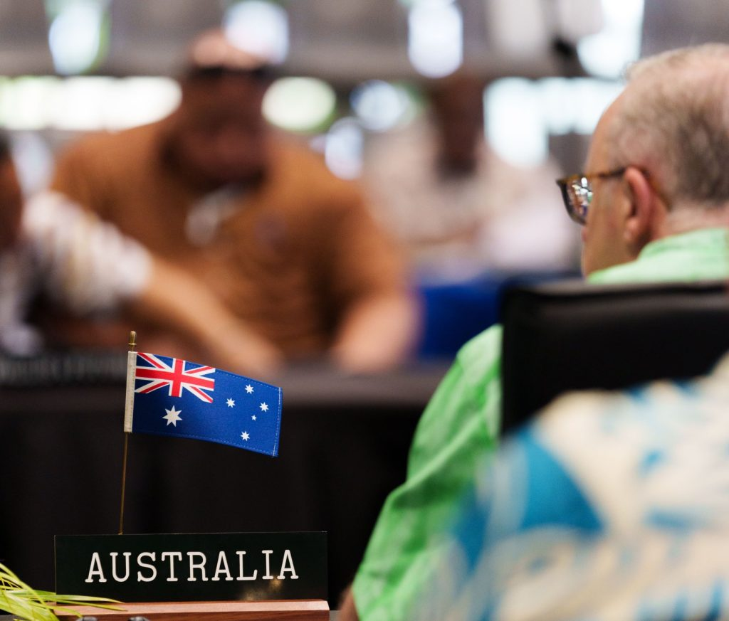
Australia took a 70-strong delegation to the Pacific Islands Forum summit, held in Rarotonga from November 6–10. (Photo: Anthony Albanese X account)
Throughout the week of the summit, Australia pursued an agenda that not only safeguarded its role in AUKUS but also promoted the strategic interests of the US in the region. It brought a 70-strong delegation to Rarotonga which spent all week holding bilateral discussions with Pacific nations and the non-Forum states in attendance — circumventing and pre-empting the decision-making processes of the Forum.
Let’s be clear, through its AUKUS membership, Australia’s interpretation of the Treaty of Rarotonga has whittled to a very narrow understanding of what “nuclear-free” means.
Ironically, Australia’s acquisition of nuclear submarines is unlikely to violate the treaty by letter, because of the loopholes it worked in during drafting. But Pacific nations are growing increasingly frustrated with Australia’s reliance on technicalities and have called out Albanese for violating the “spirit” of Rarotonga.
What’s more, we know it plans to host nuclear-capable US B-52 bombers in the Northern Territory. Australia maintains these bombers are “in-transit”, and therefore aren’t in violation of the ban on the “stationing” of nuclear weapons. But we believe the permanent, purpose-built facilities being constructed for B-52 bombers on the coast of the Northern Territory tell the real story.
It’s why a strengthened Treaty of Rarotonga is more important than ever.
A more comprehensive treaty would safeguard our nuclear-free status, and centre the peace and security of the Pacific region by excluding us as a zone of strategic competition and possible nuclear theatre in the event of war.
More immediately, we believe a stronger treaty would help address ongoing militarisation in the region. In many ways, that’s about returning to the foundations of the Nuclear Free and Independent Pacific movement, and remembering the values that helped secure the South Pacific Nuclear-Free Zone.
That goes back to 1983 when the Peoples Charter for a Nuclear-Free and Independent Pacific was adopted in Vanuatu. The charter’s vision of independence and genuine self-determination for Pacific nations was supported by 300 delegates from 180 civil society organisations around the Pacific. It challenged the domination of Pacific nations by larger powers and rebuffed the advancement of their militaries and interests over the region.
But now, it seems, there’s a new vision of security and peace for the Pacific — and it comes from Sitiveni Rabuka, the former coup leader who’s now prime minister of Fiji. Rabuka announced his “zone of peace” concept in September, but there’ve been few details, with the fullest articulation summarised in a seven-point plan that he outlined during a speech in Canberra last month.
On the surface, it appears to say all the right things. But, beyond that, it’s not about peace at all.
First, Rabuka’s zone of peace seems to follow the UN’s New Agenda of Peace, which emphasises the responsibility of states to maintain peace, domestically and regionally, while respecting the rights of sovereign nations. The seven-point plan states that Pacific nations need to have mutual respect for each other’s sovereignty and territorial integrity.
Second, it talks about the need for arms control and non-proliferation agreements, as well as environmental conservation measures. Crucially, it also argues for formal mechanisms for dispute resolution in the case of conflict, and proposes that any disputes or unrest in the region should be dealt with internally, as a matter of preference. Rabuka used the example of unrest breaking out in the highlands in Papua New Guinea. In such a case, he said, Fijian peacekeepers could be sent in.
The major flaw, however, is the fact that Rabuka’s zone of peace relies on military might to work. It doesn’t seek to disarm the Pacific or remove foreign bases. And the Pacific would remain one of the most militarised regions on earth, despite only three Pacific Islands countries having militaries.
It offers nothing to those who’ve been denied peace — and who are still grappling with nuclear legacies or fighting for independence in the Marshall Islands, Kiribati, Mā’ohi Nui, West Papua or Kanaky New Caledonia.
It doesn’t deal with the new nuclearism in the Pacific, brought on by AUKUS and the Fukushima discharge.
It doesn’t affirm the fact that climate change remains the single greatest security threat in the region, nor does it provide for Pacific priorities on climate justice, food security, migration with dignity, or a just transition away from fossil fuels.
In sum, it does nothing to address the root causes of instability in Pacific societies, like displacement, climate breakdown, lack of resources and colonial legacies. It’s a far cry from the type of “genuine security” that Pacific women have been calling for: a demilitarised and de-occupied Pacific, with concern for the safety, wellbeing and long term sustainability of our communities.
Instead, it paints a picture of a zone of peacekeeping, where we simply manage conflicts and instability among our own by having military forces ready to go.
Tellingly, Australia has emerged as one of the most passionate supporters of Rabuka’s initiative.
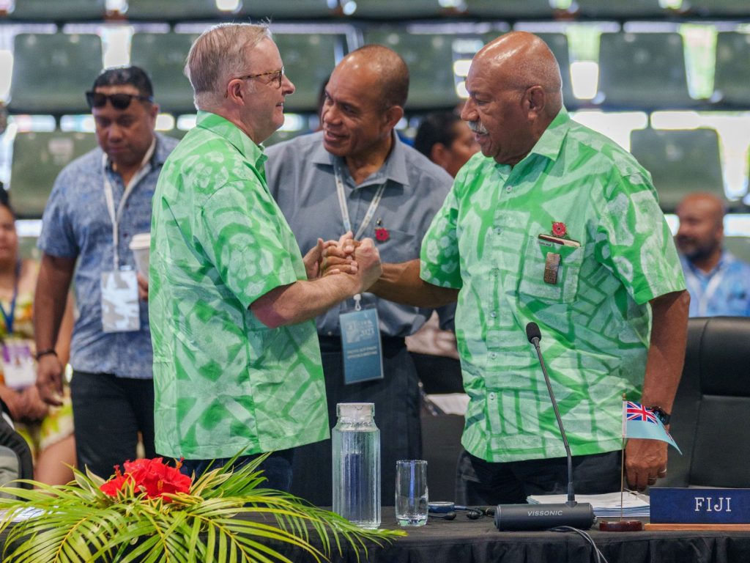
Anthony Albanese and Sitiveni Rabuka at the Pacific Islands Forum leaders meeting in Rarotonga. (Photo: Anthony Albanese X account)
Australia has played an active role in increasing militarism in the region in recent years, often branding it as aid and climate security initiatives. For example, in 2019, Australia committed $100 million in funding for the Blackrock Peacekeeping and Humanitarian Assistance & Disaster Response Camp outside of Nadi, Fiji. The camp has a military supplies warehouse and is used as a training base for Fijian security forces. It’s also an important stepping stone for the Australian Defence Force in the Pacific. In September this year, a joint AUKUS, New Zealand, and Fijian military exercise was conducted from Blackrock. Exercise Cartwheel 23 involved jungle warfare training and instruction in the use of mortars and heavy machine guns. More of these joint-exercises have been planned.
Nothing in Rabuka’s zone of peace negates the growing militarism in the region.
It also reflects another concering trend, exemplifed by Australia’s funding of Blackrock. More and more, we’re seeing the climate crisis, underdevelopment in Pacific nations, geostrategic competition, and civil unrest being “securitised” by outside powers and metropolitan nations. Everything seemingly needs a military application.
Australia, in particular, has been particularly aggressive in its approach. Of the $1.9 billion it has budgeted in aid for the Pacific over the next three years, $1.4 billion is earmarked for defence initiatives. This includes proposals to develop standing armies in the Solomon Islands and Vanuatu.
For Australia, the closet motivation is to construct a pacified sphere of influence. It’s about keeping the region aligned with its geostrategic ambitions, and keeping other powers out. Real societal stability on Pacific terms is not a priority.
And, in positioning themselves as regional peacekeepers, players like Rabuka become “partners of choice” to nations like Australia and the US. We should also note that Rabuka’s zone of peace plays to Fiji’s strengths. Fijian soldiers have been part of UN peacekeeping missions since 1978. Fijians also serve in the British Army, and there’ve been calls for a similar arrangement with the Australian Defence Force.
Rabuka’s proposal was discussed in Rarotonga, and by the end of the week, there was official support from Forum leaders. They welcomed its potential to complement other Pacific security statements such as the Boe and Biketawa Declarations, and the 2050 Blue Pacific Strategy. The Forum secretariat will provide a concept document for next year’s summit.
As for revitalising the Treaty of Rarotonga, it seemed little progress was made. As a collective, the Forum called on the US to once again ratify the treaty’s protocols. Leaders also invited the remaining members of the Forum — the Marshall Islands, Palau, and the Federated States of Micronesia (all US compact states) — to sign and ratify. Certainly this “universalisation” would be an important step, but insubstantial if the treaty is being disregarded elsewhere by a major player like Australia.
Disappointingly, Anthony Albanese and Australia appeared to have escaped any real scrutiny.
We asked whether leaders discussed the presence of B-52s in Australian territory during their retreat. Apparently, it didn’t come up. It also appeared that an “update” from Australia on AUKUS, given during a closed plenary session, has received an official thumbs-up. This is borne out by the Forum communiqué issued at the end of the summit, highlighting the “transparency of Australia’s efforts, and commitment to compliance with international law”.
At the end of it all, it was hard not to feel disheartened.
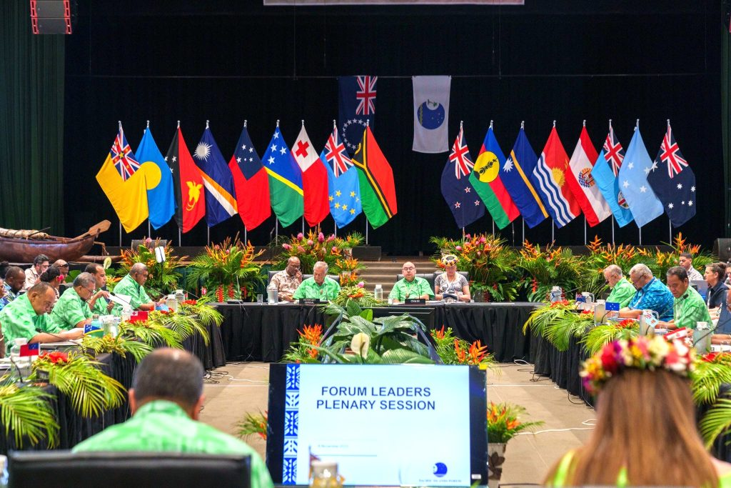
“At the core of the Pacific Islands Forum are the principles of consensus and sovereignty. But, in Rarotonga, we saw that type of decision-making actively undermined and dismantled.” — Dr Marco de Jong and Talei Mangioni. (Pictured: Pacific leaders in Rarotonga for the 52nd Pacific Islands Forum summit, from November 6-10. Photo: Anthony Albanese X account)
The Pacific Islands Forum is the Pacific’s peak regional policymaking body. It was established to ensure decisions around issues that affect all of us, such as security, climate change and nuclearism, are made with Pacific interests at the forefront.
At the core of the Pacific Islands Forum are the principles of consensus and sovereignty. But, in Rarotonga, we saw that type of decision-making actively undermined and dismantled.
We advocate for a nuclear-free and independent Pacific, knowing that a regional grassroots movement for self-determination can be powerful. It’s likely the only way we’ll get peace and stability on our own terms.
Our nuclear-free status is tied in intimate ways to our political independence — and ultimately to our survival as peoples of the Pacific. It’s how we pursue self-determination and environmental justice, while removing ourselves from the geostrategic manoeuvres of outside powers to maintain the Pacific mantra of “friends to all and enemies to none”. All of this was recognised and enshrined in the Peoples Charter for a Nuclear-Free and Independent Pacific 40 years ago.
Right now, we’re facing immense pressure to give up that legacy. More than that, leaders within our region appear to be struggling with their understanding of genuine Pacific-led regionalism. In their dealings with the superpowers, we believe they must continue to ask whose peace is being kept, and whether it’s coming at the expense of Pacific sovereignty.
Lastly, New Zealand must step up and take greater responsibility, with the understanding that our place in the Pacific is growing insecure. If Pacific nations continue to see New Zealand offering no principled difference from larger powers on wedge issues like Fukushima, deep-sea mining, fossil fuel non-proliferation, or AUKUS, we will lose our standing.
Following in Australia’s footsteps, in its approach to the region, would be an act of self-sabotage, because an undermined Pacific Islands Forum means a weakened New Zealand. It also means “zones of peace” and nuclear freedom in name only, with no room for Pacific self-determination or addressing the causes of instability.
This matters because Aotearoa can’t find security outside of the Pacific — and deepening disaster affects us all as tangata moana.

Dr Marco de Jong is a Pacific historian. This year, he completed a doctorate at the University of Oxford on the history of the environmental movement in the Pacific Islands with a particular focus on anti-nuclearism and climate change. He is now serving as co-director of Te Kuaka, an independent group promoting a progressive role for Aotearoa in the world.

Talei Mangioni is Fijian-Italian and lives and works on the lands of the Bidjigal, Birrabirragal and Gadigal peoples. She is a PhD candidate in Pacific studies at the School of Culture, History and Language, College of Asia and the Pacific at the Australian National University. Her research focuses on the creative legacy of the Nuclear Free and Independent Pacific Movement. Talei is also a board member of ICAN Australia (the International Campaign to Abolish Nuclear Weapons) and member of Youngsolwara Pacific.
Made possible by the Public Interest Journalism Fund.
© E-Tangata, 2023

